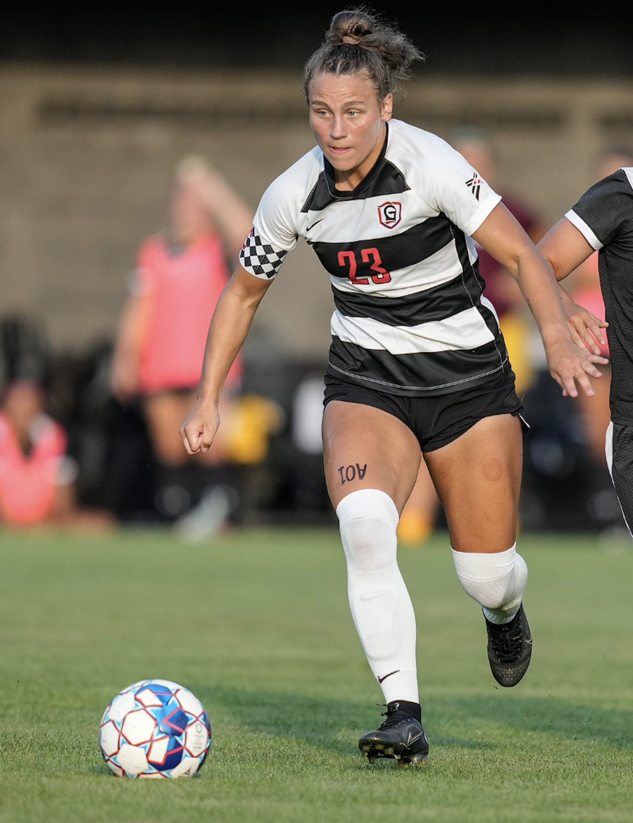
Jennifer (JJ) Aalbue #23
Cell: +1-224-239-4598
jaalbue@gmail.com

Bio DOB: August 21, 2001
Height: 5’ 6” (168 cm)
Weight: 154 lbs (79 kg)
Preferred Foot: Right
Position: M, ST, WF

Experience 2023-2024: Montreat College
12 Goals, 7 Assists
17 of 17 Appearances, 17 Starts

2023: Charlotte Eagles (WPSL)
Championship Tournament
2 of 2 Appearances, 2 Starts

2022-2023: Grace College Highlights: https://jjaalbue.com
11 Goals, 13 Assists
23 of 24 Appearances, 22 Starts
Team Captain

2022: Charlotte Eagles (WPSL)
1 Goal, 3 Assists
8 of 8 Appearances, 1 Start

2021-2022: Grace College
8 Goals, 4 Assists
12 of 23 Appearances, 8 Starts

2020-2021: Grace College
8 Goals, 5 Assists
14 of 19 Appearances, 12 Starts

2019-2020: Grace College
17 Goals, 18 Assists
23 of 23 Appearances, 23 Starts

Accolades: 4x NAIA All American (2019, 2020, 2022, 2023)
Appalachian Athletic Conference Player of the Year (2023)
Appalachian Athletic Conference All Conference (2023)
2x Crossroads League Offensive Player of the Year (2019,2022)
3x Crossroads League All Conference (2019, 2020, 2022)
NCCAA Player of the Year (2019)
3x NCCAA First Team All American (2019,2020,2022)
2x NCCAA National Tournament MVP (2021,2022)
2x NCCAA National Champion (2021,2022)

References:
Montreat College Head Coach:
Kristin Eggert, kristin.eggert@montreeat.edu, +1-630-220-8586
Grace College Head Coach:
Michael Voss, vossmd@grace.edu, +1-574-265-9951
Charlotte Eagles Head Coach:
Sam Hope, shope@maisoccer.onmicrosoft.com +1-502-905-1671

